Class: 5 A, B, C (27Apr – 03May)
Theme: Getting About the Town
(lesson 1 has to be sent by Wednesday, lesson 2 – by Friday, lesson 3 – by Sunday)
Lesson 1
Ex.1,2 p.184 (write)
Ex.5, p.185 (read)
Ex.6, p.186 (write)

Lesson 2
Ex. 1, p.186-187 (read)
Ex. 2, p. 188 (write)
Ex.1, p.189-190 (write the answers)

Lesson 3
Ex. 5, p.192 (write)
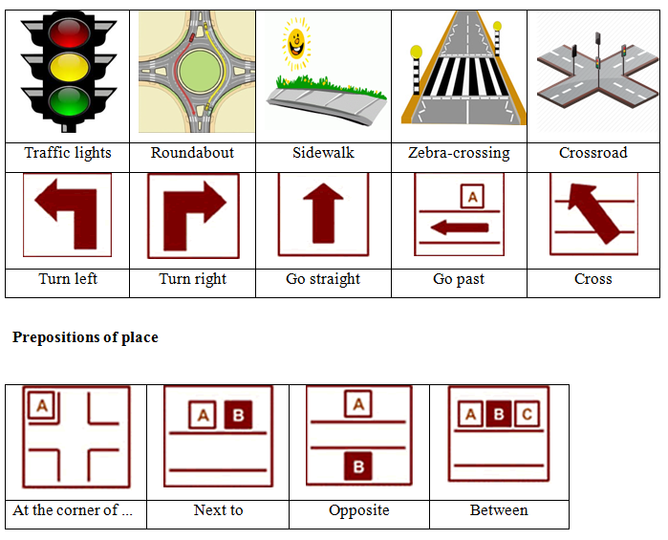

- HOSPITAL. Go along River Street. Take the second turn on the left. Go along Oak Street. Keep on going straight after crossing the road at the traffic lights. It’s on your right.
- TRAIN STATION. Go along River Street. Take the last turn on the left. It is next to the Gas Station.
- RESTAURANT. Take the first turn on the left and then the first turn on your right. Go straight. It is on the left of the traffic lights.
- LIBRARY. Go straight. It is opposite the Bank.
- POST OFFICE. Take the first turn on the left and then turn right. Go straight Lane Street. Cross the road at the traffic lights and keep on going straight. At the crossroads of Lane and Park streets turn right. It is opposite the Train Station
Write me the direction to SUPERMARKET and SCHOOL
(Use the examples above.)

